The activation functions.
To better understand the role of the activation function, let us assume a person is performing some work. To make the work more efficient and to obtain exact output, some force or activation may be given. This activation helps in achieving the exact output. In a similar way, the activation function is applied over the net Input to calculate the output of an ANN.

The information processing of a processing element can be viewed as consisting of two major parts: input and output. An integration function (say f) is associated with the input of a processing element. This function serves to combine activation, information or evidence from an external source or other processing elements into a net input to the processing element. the nonlinear activation function is used to ensure that a neuron's response is bounded - that is, the actual response of the neuron is conditioned as a result of large or small activating stimuli and is thus controllable.

Certain nonlinear functions are used to achieve the advantages of a multilayer network from a single-layer network. When a signal is fed through a multilayer network with linear activation functions, the output obtained remains same as that could be obtained using a single layer network. Due to this reason, nonlinear functions are widely used in multilayer networks compared to linear functions.
There are several activation functions as follows…
1.Identity function:
It is a linear function and can be defined as

f(x) = x for all x
The output here remains the same as input. The input layer uses the identity activation function. The graphical representations identity function is Shown in Figure (A) below.
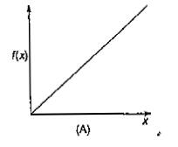
2.Binary step function:

This function can be defined as
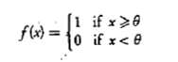
where θ represents the threshold value. This function is most widely used in single-layer nets to convert the net input to an output that is a binary (1 or 0). The graphical representation is shown in Figure (B) below.
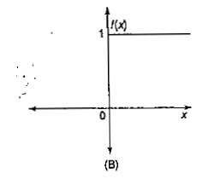

3.Bipolar step function:
This function can be defined as
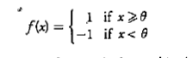
where θ represents the threshold value. This function is also used in single-layer nets to convert the net input to an output that is bipolar (+ 1 or -1). The graphical representation is shown in Figure (C) below.

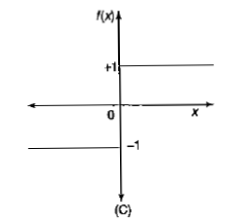

4.Sigmoidal functions
- The sigmoidal functions are widely used in back-propagation nets because of the relationship between the value of the functions at a point and the value of the derivative at that point which reduces the computational burden during training.

- The main reason why we use sigmoid function is because it exists between (0 to 1). Therefore, it is especially used for models where we have to predict the probability as an output. Since probability of anything exists only between the range of 0 and 1, sigmoid is the right choice.

Sigmoidal functions are of two types:
I. Binary sigmoid function:
It is also termed as logistic sigmoid function or unipolar sigmoid function.
It can be defined as.
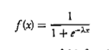
where λ is the steepness parameter.
The derivative of this function is
The function is differentiable. That means, we can find the slope of the sigmoid curve at any two points. Here the range of the sigmoidal function is from 0 to 1. The graphical representation is shown in Figure (D) below.
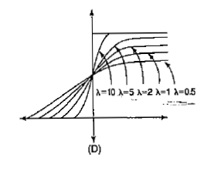

II. Bipolar sigmoid function:

This function is defined as
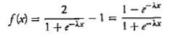

where λ is the steepness parameter and the sigmoidal function range is between -1 and+ 1. The derivative of this function is
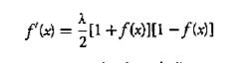
The graphical representation is shown in Figure (E) below.

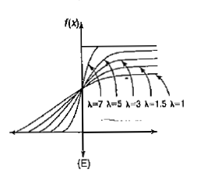

The bipolar sigmoidal function is closely related to hyperbolic tangent function, which is written as
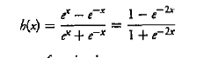
The derivative of the hyperbolic tangent function is

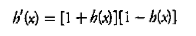

If the network uses a binary data, it is better to convert to bipolar form and use the bipolar sigmoidal activation function or hyperbolic tangent function.

5.Ramp function:
The Ramp function is defined as
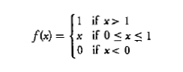
The graphical representation is shown in Figure (F) below.
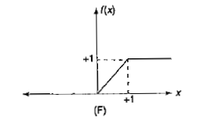
6.Piecewise linear
The rectified linear activation function is a piecewise linear function that will output the input directly if is positive, otherwise, it will output zero. It has become the default activation function for many types of neural networks because a model that uses it is easier to train and often achieves better performance

The rectified linear activation function is the most used activation function. Since, it is used in almost all the convolutional neural networks or deep learning.

It is a relatively newer type of activation functions used in neural networks and they have a simple mathematical form g(z)=max{0,z}. Graphically, they look like the plot below:

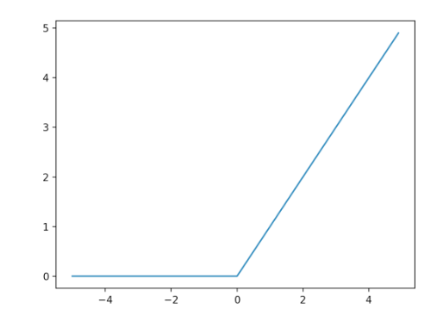

Piecewise linear function is better for the training of deep neural networks when compared to the traditional smoother sigmoid or tangent activation functions. In general, it is difficult to predict in advance which activation function would work best in a given scenario and hence, trial and error is involved to a certain degree to figure out the best activation function.

